Joint Field Office
Raleigh, NC
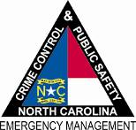

North Carolina Department of
Crime Control & Public Safety

April 29, 2011
NC-1969 – MA 001
FEMA/State News Desk: 919-779-8371

Media Advisory

WHO: NC Division of Emergency Management/FEMA

WHAT: Joint Disaster News Desk

WHEN: Effective April 29, 2011

WHY: To provide the media with a direct line to state/federal recovery efforts in connection with the April 16, 2011 storms and tornadoes.

HOURS: The news desk is operational from 7 a.m. to 7 p.m., seven days a week, and is monitored 24 hours a day.

NUMBER: 919-779-8371

The state contact number remains 919-715-3747.

###

