Public Participation Plan 2023

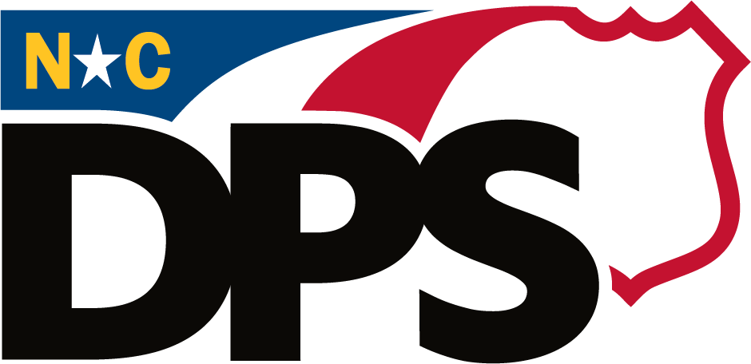

Table of Contents
Introduction 3
Purpose 4
Public Meetings 4
Public Engagement 5
Website Elements 5
Notifications 6
Plan Maintenance 7

Introduction

The North Carolina Department of Public Safety (NCDPS) recognizes that all citizens of North Carolina have the right to access government services and to meaningfully contribute to government decisions. Building a more inclusive society affects and requires the participation of all North Carolinians. Outreach to and engagement with North Carolina’s residents is critical for NCDPS to be successful in meeting its mission to safeguard and preserve the lives and property of the people of North Carolina through prevention, protection, and preparation with integrity and honor.

To this end, the NCDPS Public Access and Participation Plan includes the commitment to:

- Develop staff capacity to represent NCDPS to the public, and to be responsive to citizens who contact the Department seeking help;
- Continually review how the public accesses NCDPS, to promote transparency, and better enable meaningful participation; and
- Strive for continuous improvement in the areas of public access, participation, and engagement.

Purpose

The purpose of this plan is to ensure consistency across the Department in both the understanding and implementation of public access, participation, outreach, and engagement strategies. NCDPS recognizes public engagement is an active and intentional dialogue between members of the public and NCDPS.

By applying the guidance and best practices presented in this plan, NCDPS aims to:

- Create better opportunities and mechanisms to receive public input.
- Promote respectful and meaningful dialogue between community members, organizations, and the Department.
- Educate the public about the Department’s programs.
- Build trust with the public to strengthen community ties and partnerships.
- Work with community organizations to identify shared goals and opportunities for collaboration.
- Work with the public on strategies to improve future public engagement.
- Develop communication plans, as needed, that promote outreach to underserved communities.

Public Meetings

There is no “one size fits all” approach to public involvement. NCDPS continues to use a variety of comprehensive, tailored methods and strategies to facilitate meaningful public involvement. Public meetings are important to the public’s access to NCDPS and to public understanding of NCDPS plans and actions. They are an opportunity for NCDPS to engage communities whose opinions may have been overlooked.

To improve public engagement and access, NCDPS shall:

- Review existing practices governing the conduct of agency public meetings, and make adjustments if needed to promote greater access and meaningful public engagement; and
- Adopt the goal of ongoing improvement of public access and public participation.

In their review of existing practices governing the conduct of public meetings, NCDPS Divisions are encouraged to consider the following actions which can remediate barriers to participation:

- Timing: Adopting timing of informal public meetings at different hours of the day and days of the week to increase the likelihood of getting more representative participation when applicable.
- Publicity: Publicizing using various media to promote meeting attendance.
- Outreach Intermediaries: Utilizing indirect methods of outreach to publicize proposed agency actions, including coordinating with intermediary organizations that possess their own networks.
- Venues: In addition to providing virtual meeting locations, adopting a variety of locations accessible to underserved communities, and ensuring that venues are physically accessible.
- Languages: Providing translation in American Sign Language and the top two spoken languages of a community, as determined by the most recent census.
- Non-Technical Information: Providing relevant information and data to the public in a manner that is easily understandable.
- Varied Means of Input: Providing multiple means of public input, augmenting in-person and virtual meetings, to include telephone, email, online comment portals, surveys, polls, and other means. And when able, making recordings of meetings available to the public.

Public Engagement

NCDPS will continue to look for appropriate opportunities to improve community engagement and outreach efforts, especially in underserved communities. NCDPS continues to consider geography, available community information, and other relevant data to reach key constituencies and stakeholders. NCDPS’s public engagement and outreach efforts may include:

- Distributing media releases when events are posted for public notice and public comment.
- Posting to social media to raise awareness for public notice and public comment events.
- Communicating with interested parties, such as community members, local and Tribal governments, community organizations and non-profit organizations that have expressed an interest in or may be directly affected by the Department’s proposed action.
- Meeting in-person with interested parties to address issues of concern.
- When contacted, directing members of the public to the proper staff contacts within NCDPS or other appropriate agencies.

Website Elements

Making sure the NCDPS website is designed with a focus on a positive user experience allows the Department to increase web-traffic and engagement while improving the public’s understanding of agency goals and activities.

NCDPS will continue to:

- Review all website language describing agency policies, programs, and processes, and, where necessary, update content with clear, plain-language statements.
- Consult with other state agencies that have taken steps to improve access to their websites.
- Regularly check public facing contact information to ensure quick and direct access to departmental contacts.
- Review website for ADA compliance.

NCDPS will strive to:

- Convey technical information in a clear and accessible manner.
- Incorporate translation service on public-facing NCDPS web-based content. Uploaded documents may be translated from English to Spanish depending on the subject matter.
- Make available multiple methods for the public to provide input through the NCDPS website and otherwise. This could include telephone, email, general comment portals (webforms) and other means.

Notifications

Meetings of public bodies required by law to be noticed can be found on the North Carolina Secretary of State’s searchable public meetings calendar, https://www.sosnc.gov/online_services/calendar/Search, usually within 15-30 days of the meeting and includes all elements for who, what, when, where, why and how.
However, members of the public may have varied access to technology and internet. Therefore, it is important for the Department to continue to practice different methods of communication and outreach to help ensure public notices reach an external audience.

Flyers can be effective at beginning dialogue with a particular community. Venues where information can be posted that may have higher concentrations of vulnerable populations (i.e., children, the sick, elderly, etc.) or shared spaces underserved community members may frequent include:

- Schools
- Places of worship
- Tribal facilities
- Locally owned businesses
- Restaurants
- Nursing homes
- Public libraries
- Community colleges and universities
- Community centers
- Subsidized housing complexes
- Local government buildings
- Laundromats

In many communities, information about events happening in the area are circulated via social media platforms. Given the wide reach and broad use of these platforms, the Department publicizes events and notices on NCDPS’s social media platforms.
Email lists are an additional method for distributing notices. Online sign-up for NCDPS news releases is available on the NCDPS website. Divisions may also provide opportunities to sign up to receive email notification for updates on specific types of proposed activities.

Radio can be an effective method to notify certain stakeholder groups in rural areas about public notices or events. Radio ads or outreach may be considered where appropriate and as resources allow.

Plan Maintenance

NCDPS will review this plan annually and update as needed to ensure the Department continues to promote public access and participation.

