Grants Management Guidelines

2022 – 2023 EDITION

Incorporating guidelines and amendments effective August 13, 2020, and later

September 1, 2022

Dear GCC Subrecipients and Applicants:

The Governor’s Crime Commission is here to support you in the grant process to ultimately make our state and communities safer and healthier. We provide funding for various grant programs that support law enforcement equipment, training and direct services to victims. We support justice involved youth and work towards equity in the justice system.

To that end we are excited to have you engage with us. We encourage your questions and feedback throughout the process. We are committed to customer service, and you are our customers. We are here to help make the grant process as smooth and as collaborative as we can. These grants are an important part of supporting your work with victims and with the justice system.

GCC’s grants have become more competitive than ever. In 2022 we had 540 applicants asking for over $112 million, yet our new grant funding was budgeted at just under $47 million. One reason for the increased need for funding is the increasing need for services in our communities. Our commissioners had to make hard decisions based upon what they saw as the greatest need for assistance to help the residents of North Carolina. This information is provided not to discourage you from applying for our 2023 grants, but for you to understand how the increased needs across our state impact grant award availability.

In addition to grants, GCC also houses the Criminal Justice Analysis Center and the Justice Data Portal. This important work supports you and your elected officials to make data informed decisions. We are adding more data to the portal regularly which will be helpful as you move through the grant process.

Our training workshops have traditionally been an opportunity for you to meet our staff and for them to meet you. Our staff has worked hard to provide opportunities to learn during live and recorded events, thru online modules and via this manual. You are encouraged to learn and ask questions. Get to know our team and introduce yourself. Please let us know if there is anything that we can do to assist you.

Sincerely,
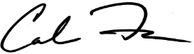
Caroline Farmer

Contents
1 INTRODUCTION 7
2 OPENING YOUR AWARD 8
2.1 Introduction Letter 8
2.2 Grant Period of Performance 8
2.3 SAM.gov and Unique Entity Identifier Registration 8
2.4 Notice of Grant Implementation 9
2.5 VOCA Subaward Report (ISAR) 9
2.6 Technical Support/Customer Service 10
2.7 Online Training 10
2.8 GCC Online Resources 10
3 REIMBURSEMENTS 11
3.1 Reimbursements Overview 11
3.2 Reimbursement Timeline 11
3.2.1 Reimbursement Deadlines 11
3.2.2 End of Grant Reimbursements 11
3.2.3 Reimbursement Review Process 11
3.2.4 Documentation and Page Number Labelling 12
3.2.5 Contract Reimbursement Requirements 12
3.2.6 Personnel Reimbursement Requirements 18
3.2.7 Equipment and Supplies Reimbursement Requirements 21
3.2.8 Travel Reimbursement Requirements 23
4 COST PRINCIPLES AND ADJUSTMENTS 26
4.1 Cost Principles 26
4.2 Direct and Indirect Costs 26
4.2.1 Direct Costs 26
4.2.2 Indirect Costs 26
5 Adjustments 27
5.1 Budgetary Adjustments 28
5.1.1 Purpose of Budgetary Adjustments 28
5.1.2 Budgetary Adjustment Affects Grant Indirect Cost Awards 28
5.2 Non-budgetary Adjustments 29
5.2.1 Grant Period Extensions 29
5.2.2 Grant Scope and Programmatic Changes 29
5.3 Personnel Changes 30
5.3.1 Persons Affected by Personnel Adjustments 30
5.3.2 Changing the Authorizing Official or Project Director 30
5.3.3 Changes to Positions Specified in the Grant Application 32
6 MONITORING & UTILIZATION 35
6.1 6 Monitoring Overview 35
6.2 Monitoring Process 35
6.2.1 Desk Review 35
6.2.2 On-Site Visits 35
6.2.3 On-site Visit Process and Requirements 36
6.3 Use of Funds 37
6.3.1 Appropriate Usage of Funds 37
6.3.2 Timely Usage of Funds (Utilization) 37
6.3.3 Monthly Reimbursements 38
6.4 Risk 38
6.4.1 Risk Assessment 38
6.4.2 Risk Ratings 38
6.5 Holds Affecting your Grant 39
6.5.1 Organization Level Holds 39
6.5.2 Grant Level Holds 39
7 REPORTING 40
7.1 Audit (Financial) Reporting 40
7.1.1 Level I (Less than $25,000) 40
7.1.2 Level II ($25,000 – 499,999) 40
7.1.3 Level III ($500,000 - $749,999) 40
7.1.4 Level III+, ($750,000+) 41
7.2 VOCA Subgrant Award Report 41
7.2.1 VOCA SAR Report Process 41
7.3 GCC Project Progress Report 41
7.3.1 Progress Report Coverage Periods 42
7.3.2 Progress Report Due Dates 42
7.3.3 Progress Report Process 42
7.4 Performance Management Tool (PMT) Report 42
7.4.1 PMT Report Due Dates 42
7.4.2 Submitting a PMT Report 43
7.4.3 Federal PMT Site Technical Difficulties 43
7.5 CJA & JJ Federal Reports 43
7.6 CJA & JJ Report Periods and Due Dates 43
7.7 VAWA Federal Progress Reports 44
8 CLOSING AWARDS 45
8.1 Review of Utilized Funds 45
8.1.1 Match Requirements 45
8.1.2 Final Reimbursement 45
8.1.3 Return of Funds 45
8.1.4 Reverted Funds 46
8.2 All Required Reports are Submitted 46
8.3 Disposition of Equipment and Unused Supplies 46
8.4 Administrative Closure 46
8.5 Post-Closeout and Continuing Responsibilities 46
8.5.1 GCC Recovery of Funds Allowed After Closure 46
8.5.2 Federal Documentation Retention Rules 46
8.5.3 State Subrecipient Additional Document Retention Rules 47
9 OTHER RESOURCES 48
9.1 Acronyms 48
9.2 Links 50

INTRODUCTION
Congratulations on receiving a grant through the North Carolina Governor’s Crime Commission (GCC). The GCC staff is here to help guide you through the process of administering your awarded grant, often referred to as a project. The terms “grant” and “project” are used interchangeably within this Guidebook.

The next several sections of this Guidebook will focus on policies and issues pertaining to the administration of your project including Opening Award, Reimbursements, Budget Adjustments, Monitoring and Utilization, Reporting, and Closing Award.

Each project is assigned a Grant Administrator within the Grant Management division of GCC. This person serves as a resource for you and should be viewed as a member of your project team. This is your primary point of contact for all post-award issues, including reimbursements, reporting requirements, and grant adjustments. Your Grant Administrator has been trained to understand the details of a U.S. Department of Justice Grant, GCC policies, and the online Grants Enterprise Management System (GEMS). In addition to providing grant and technical assistance, your Grant Administrator is charged with oversight and monitoring duties which are discussed in future sections of this Guidebook.

OPENING YOUR AWARD
Per North Carolina Administrative Code, grantees have 30 days from the date the grant is awarded and delivered to accept and return all award documents to GCC. If your agency requires further time to process award acceptance, you must contact GCC before the 30-day window expires.

Once you have signed and mailed in (or completed in DocuSign) your completed Grant Package, a member of the GCC Administrative Team will review the grant information you have submitted and uploaded in GEMS to ensure all certifications, policies, and other required documentation have been included for the opening of your project. You will be contacted by a member of the GCC Administrative Team should your grant package be incomplete and advised on necessary corrective steps. Each project must have the following policies attached in GEMS:
- Conflict of Interest
- Procurement of Purchasing
- Unlawful Discrimination
- Whistleblower
- Travel (if travel is to be incurred)
(Based on the source of your grant, there may be other policies required. Work with your Grant Administrator to determine what is required for your specific situation.)

After all grant information is received and completed, the project will be forwarded to the Grant Administrator Supervisor who will notify the Grant Administrator the project is ready to be opened.

Introduction Letter
Your project will be officially opened after all reviews are completed. At this point, you will receive an introduction letter from your Grant Administrator via e-mail. The introduction letter will contain additional processes to complete, documents and information specific to your project. While this is a lengthy letter, please read the entire document as it contains vital information. The introduction letter should also include your Grant Administrator’s contact information, so you can easily contact for support.

Grant Period of Performance
The U. S. Department of Justice specifies general Federal award information in the terms and conditions of the Federal Award. The Federal award information includes the period of performance which is the official start and end date of your project. NOTE: You will not be reimbursed for any expenses or encumbrances of funds occurring before your project start date or after your project end date.

SAM.gov and Unique Entity Identifier Registration
All GCC subrecipients are required on the Federal System for Award Management (SAM) to have a Unique Entity Identifier. Subrecipient SAM records are publicly viewable and require a Unique Entity Identifier (UEI) number which may be obtained viahttps://www.sam.gov.

Notice of Grant Implementation
Before beginning any grant activities, the Project Director needs to complete and submit a Notice of Grant Implementation in GEMS. This is a short narrative of how grant funds will be implemented. It explains the steps your organization will take to ensure the project is administered according to federal and state regulations. Please be sure to include details on procurement, documentation, and financial reporting.

Submit the Notice of Implementation as follows:
- Log into GEMS and navigate to the current project.
- Select “Notice of Implementation” from the left-hand menu.
- Once the submission is ready, select the blue “SAVE” button. This will be sent to your GCC Grant Administrator for review. You will receive a confirmation once the submission is reviewed and approved.

VOCA Subaward Report (ISAR)
The Initial Subaward Report (ISAR) is for VOCA projects only. This must be completed in GEMS and submitted to GCC immediately after receiving notification your ISAR is available in GEMS, which will be prior to Project Opening. Details of the process are below:
- The ISAR information reported in GEMS is required to complete Part 1 in the OVC-PMT website which enables the subrecipient to submit PMT reports for each project. Make sure to correctly enter all information.
- The Grant Administrator will complete Part 1 of the ISAR by adding the new sub-award under the current, open project. The Grant Administrator will then email the subrecipient to complete Part 2 of the ISAR.
- Once Part 2 is completed, you should email your Grant Administrator. The Grants Administrator will then review and approve the ISAR and you will be ready and able to submit the required PMT reports.

GCC staff cannot address any technical issues with OVC-PMT’s website or system. You must contact the OVC-PMT Help Desk at https://ovcpmt.ojp.gov, or via telephone at 1-844-884-2503. Customer support is available Monday–Friday, 8:00 a.m. – 5:00 p.m. ET.

Technical Support/Customer Service
Using the contact information (phone and email address) of your assigned Grant Administrator, you can reach out to your assigned Grant Administrator with questions regarding your grant or for technical assistance. Please be sure to review all communications from your Grant Administrator and timely respond to any requests for action. Your Grant Administrator may contact you to remind you of a reporting deadline, ask questions about submitted documentation, or schedule a review or site visit. Additionally, from time to time, your Grant Administrator will reach out to you for updates on the progress of your project.

Online Training
GCC has finalized an online learning platform – referred to as the Learning Management System (LMS). This is an interactive tool that includes a series of presentations designed to walk you through many important aspects of the administration of your GCC grant. By completing the LMS modules, you will understand many of the administrative concepts, see examples of GEMS, and test your knowledge. All Project Directors, Financial Officers, and Authorizing Officials have access to LMS. GCC can provide access to others working on the grant.

GCC Online Resources
GCC maintains a frequently updated web page at https://ncdps.gov/gcc. You are strongly encouraged to visit the GCC website for information pertaining to grant application dates and deadlines, grant workshops, GCC quarterly meetings, grant resources, forms, etc. Examples of some of the resources maintained are listed below:
- Staff Contact Information: https://www.ncdps.gov/gccstaff
- GCC Grant Forms: https://www.ncdps.gov/gccforms
- GCC Grant Resources: Resources | NC DPS

REIMBURSEMENTS

Reimbursements Overview
A reimbursement request is a process by which GCC releases grant funds to the subrecipient upon demonstrating that submitted expenses were allowable, allocable, reasonable, and necessary to the success of the project.

Proof of payment must be submitted before any reimbursement can be processed.

Some things to keep in mind about reimbursements:
- Budgeted items may be determined to be unallowable at any point in the grant based on statutory grant authorization or other regulatory requirements.
- The agency must have completed the purchase, paid in full, and have evidence that payment was made. Purchases must comply with the grant agreement and be within budget.
- Federal Funding is not a method to use to entirely run a program for life. It is an opportunity to assist in building financial stability for a program until grants are no longer needed.

Agencies are recommended to have at least 3-4 months back up savings in funds to support the program. This can assist with reimbursement delays or issues that may arise so as not to cause the program to stop services based on financial hardships.

Reimbursement Timeline

Reimbursement Deadlines
The subrecipient will submit all expenditures monthly unless there is no reimbursable activity in each month. Expenses must be filed by the end of the month following the month in which grant funds were incurred by the subrecipient. For example, expenses incurred in January must be filed for reimbursement by the end of February. Any reimbursement requests submitted later will be subject to delays in the review and payment processes.

Examples of determining when funds are incurred include:
- Equipment, Supplies. When the purchase transaction begins either by way of creation of a purchase order (internally) or via an order sent to the vendor (if purchase orders are not required).
- Personnel. When the work was accomplished.
- Utilities. When the utility service was provided.
- Rent. When the rent became due.

End of Grant Reimbursements
Subrecipients have 60 days after the end of the grant period of performance to submit their final reimbursements and supporting documents. Any reimbursements in New or Pending Financial Officer Approval status are not considered submitted and may be rejected if not properly received by the end of the 60-day submission window.

Reimbursement Review Process
After they are received, reimbursements received by GCC are processed as follows:
- Reports Must be Current. Your grant must not have any overdue reports. Should any reports be overdue, reimbursements will not be processed; GEMS will place a hold on the project.
- Received On-time. Grant administrators will review requests within 10 days of being received.
- Received Late. Grant administrators have up to 30 days to review reimbursements received beyond their due date.
- Corrections. If your grant administrator finds errors in a reimbursement request, it will be returned as “modifications required”. After the corrections are made and the request is re-submitted through the financial officer, the grant administrator has up to ten days to review the corrections. Should further corrections be necessary, the request will be returned followed by contact by the grant administrator.

Documentation and Page Number Labelling

Document Labelling and Contents
All documents will be labeled consistently by expense category. All documents must be legible, viewable, and must be in PDF format.

The subrecipient will label all documents consistently according to category. Documents submitted must be legible and viewable. Examples:
- PERSONNEL - October-2020 – (AGENCY NAME & PROJECT: PROJ00000)
- EQUIPMENT - November 2020 – (AGENCY NAME & PROJECT: PROJ00000)
- SUPPLIES - December 2020 – (AGENCY NAME & PROJECT: PROJ00000)

Page Numbering
All uploaded documents must have page numbers (sequential) and those page numbers must be entered in the “Document #” column of the respective coversheet.
PERSONNEL Starts with P1…. P2…P3…. Etc.
SUPPLIES Starts with S1…S2…. etc.
EQUIPMENT starts with E1…E2…etc.
TRAVEL starts with T1…T2……etc.

Contract Reimbursement Requirements

Drafting and Approval of Contracts
All contracts must be approved by GCC prior to execution. Further, approved and executed contracts must be uploaded into GEMS before requesting any reimbursement.
- Prior to execution, submit a copy of the proposed contract along with a completed GCC Contract Approval form to your grant administrator.
- If for any reason the subrecipient is requesting an excess rate above the $81.25 hourly standard rate, the appropriate excess rate form must be submitted prior to submitting the contract for approval
- Once the contract is approved, the subrecipient may execute the contract with the contractor and upload both the signed contract and the approval document to GEMS.
- If a contract expires during the time of a project period of performance, a new contract must be approved and uploaded into GEMs prior to any reimbursements being submitted for that contract line.

Contract Reimbursement Documentation
Documents necessary for contract reimbursements.
- Contractor invoice
- Proof of payment
  - Paid/cleared check, electronic banking confirmation

- Contractual Cover Sheet
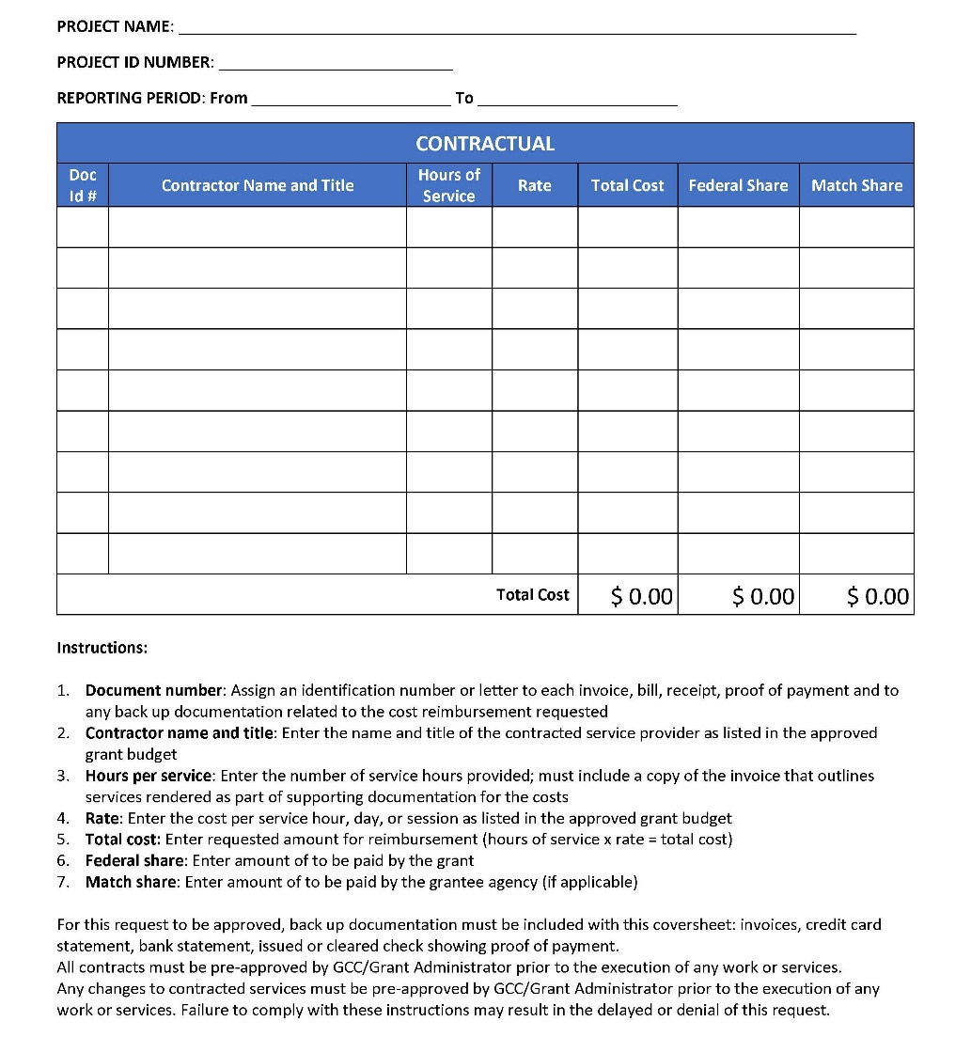

Pre-contract Request Form (Sample)
Current form available here:
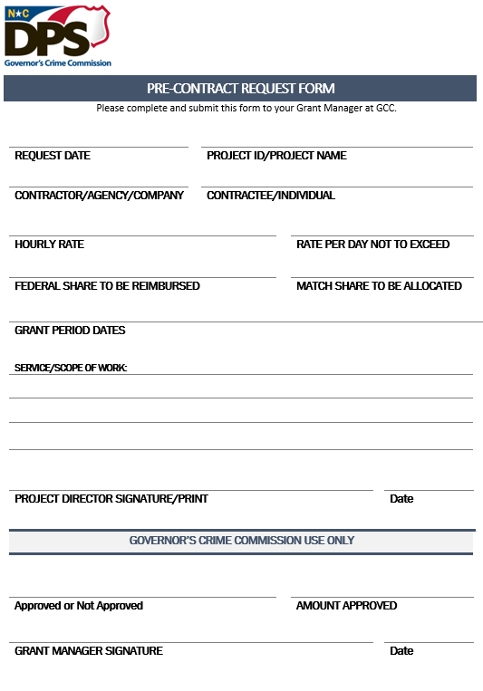

Excess Rate Request (Sample)
Current form available here:
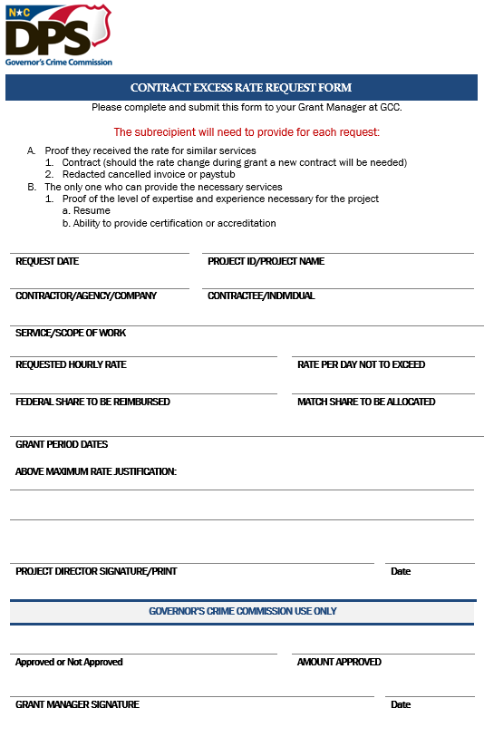

Contract Template (Sample)
Current form available here: Can be used as a contract, for comparison, or as a guide to create your own contract.
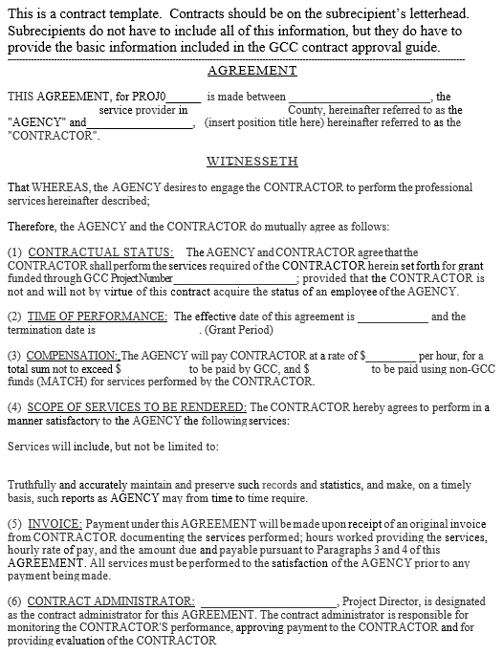
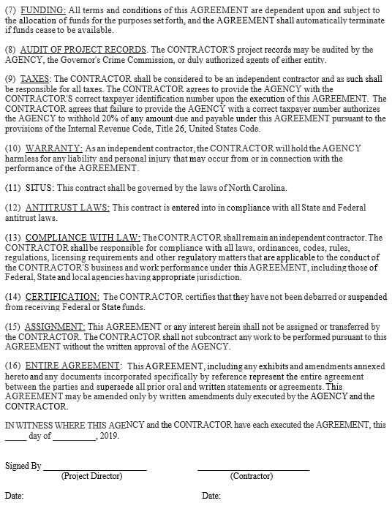

Personnel Reimbursement Requirements
Discuss specific document requirements with the grant administrator, if necessary.
- Cover page
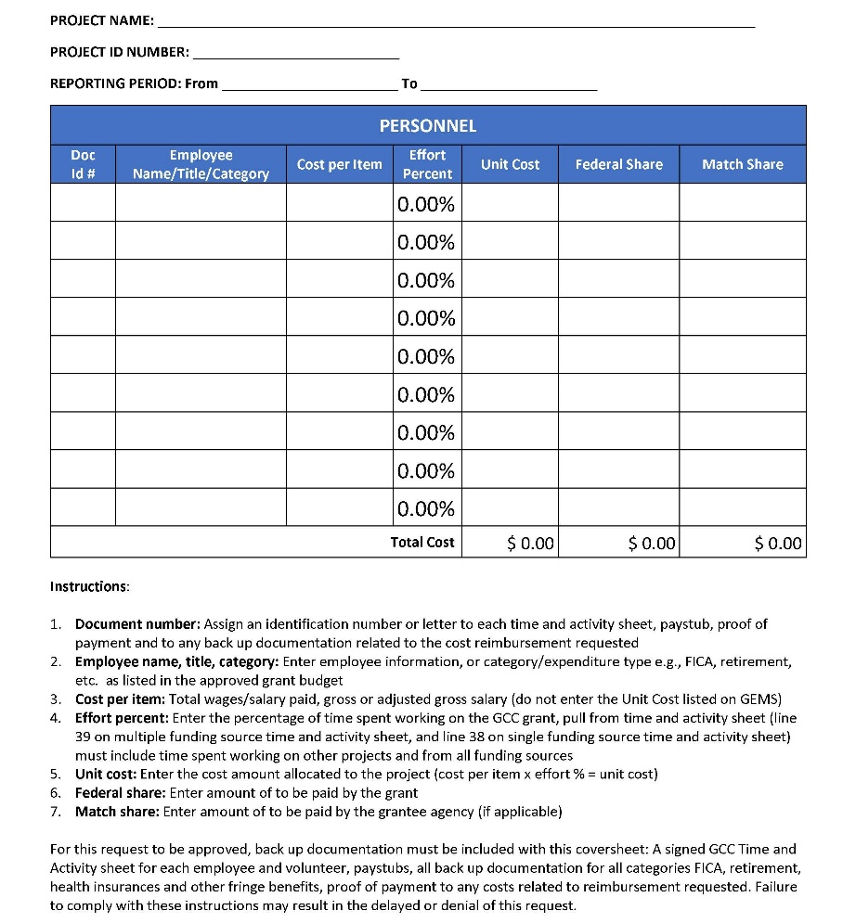

- Time and Activity sheets
Time and activity sheets come in two forms: single source/volunteer match or multiple sources. Make sure to choose the right form for everyone.
  - The single sole source form is used for documenting a volunteer match and for personnel who are sole-sourced 100% on a single project.
    - Make sure to enter the employee’s full name and position title accurately.
    - Make sure correct project numbers are included on all documentation prior to submission.
    - Enter all work hours and enter the appropriate activity codes for work performed.
    - Make sure the employee and supervisor have signed the time and activity sheet.
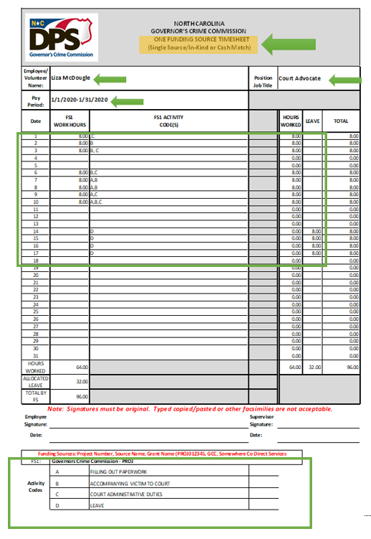

  - The multiple funding source form is used for personnel paid through more than one project or funding source.
    - Make sure to include ALL funding sources and time worked for the entire month. We need to verify all hours worked for GCC and other sources to total a full month of hours worked and how these hours were allocated
    - Complete all hours worked based on actual activity.
    - Make sure the effort percentages are correct and reflected on the cover page.
    - Enter activity codes according to actual activities worked.
    - Signed and dated by employee and supervisor.
    - Make sure the project number is entered and is consistent with the cover page.
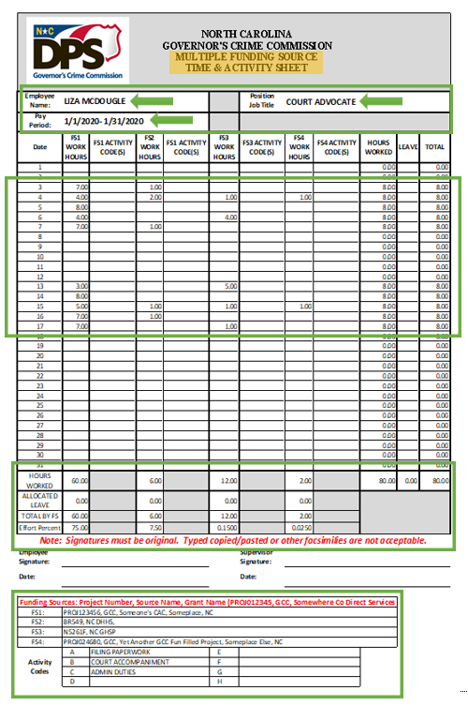
- Fringe benefits
  - Include allocation share for projects, benefits documentation, invoices, and proof of payment
- Payment proof
  - Paid/cleared check
  - Pay stubs
    - Provide a complete pay stub
    - Must have the full name of employee
    - Must show the time period worked
    - Must show/be accompanied by bank draft payment

Equipment and Supplies Reimbursement Requirements
Discuss specific document requirements with the grant administrator, if necessary.
  - Equipment
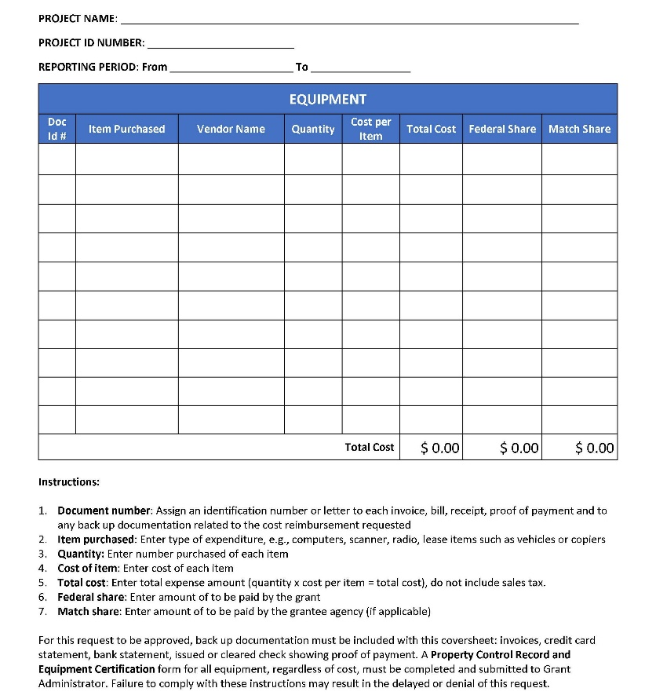
  - Supplies
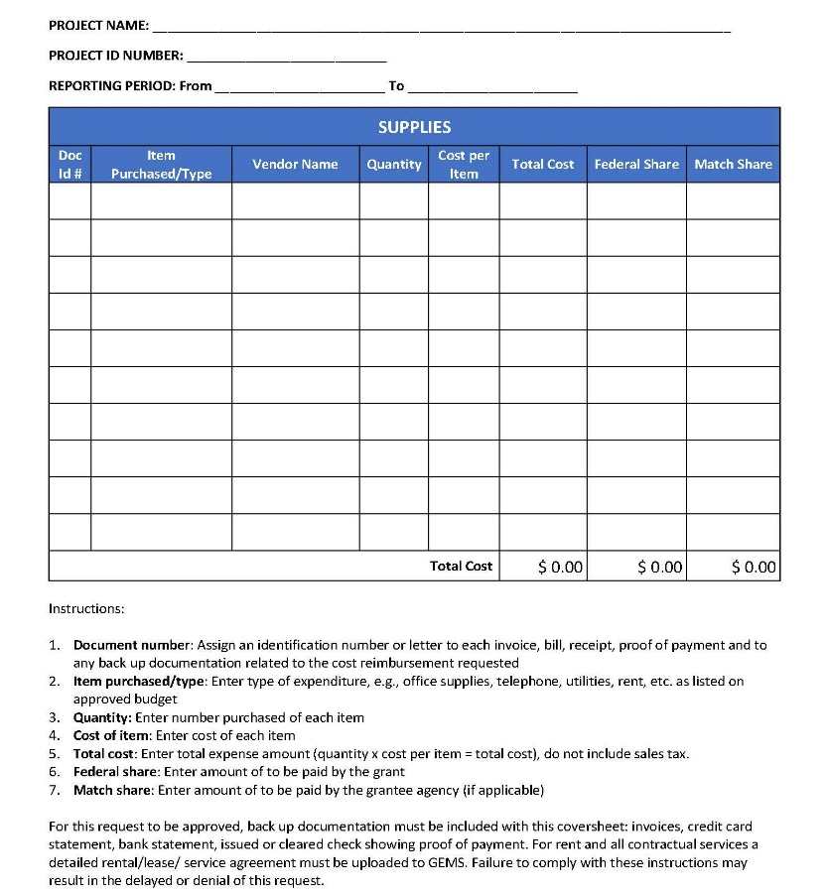

- Purchase order or proof of date funds encumbered. May be order date on the invoice.
- Bids/quotes (three, if required) or APPROVED sole source request
  - NOTE: GCC requires three informal bids/quotes for any procurement valued above $10,000. If your agency requires bids/quotes at a lower level, that threshold applies.
  - Split procurement (dividing a purchase to appear to be below the bid threshold) is not allowed. If discovered, your reimbursement may be disallowed.
- Invoice
- Proof of payment
  - Paid/cleared check
  - Electronic banking confirmation
  - Vendor confirmation
    - Receipt
    - Zero-balance invoice (must be received from the vendor showing no balance due)
    - Other vendor-supplied documentation that payment received (must be approved by grant administrator)
- Property Control Record and Equipment Certification
- * Vendor debarment checks
  - SAM.gov
www.sam.gov
  - NC Purchase and Contract
https://ncadmin.nc.gov/documents/nc-debarred-vendors
- ** Purchase specific policies/procedures (contact grant administrator for requirements)
- ** Photos of items (contact grant administrator for requirements)

* Must be completed. Include in Byrne-JAG grants. Include in other grants when directed.
** Must be completed and included for Byrne-JAG grants. Completed/included in other grants when directed.

Travel Reimbursement Requirements
Any travel must be directly related to the project objectives.

Out of-State Travel Prior Approval
All out-of-state travel for training or conferences must receive prior approval from your Grants Administrator prior to attending and paying any travel or registration expenses. Before attending or planning the conference make sure to inform your Grants Administrator of your plans to travel out of state for conferences or training. Send an email including the link to the conference and any hotel/travel information you have available.

Travel Reimbursement Documentation
- Cover page
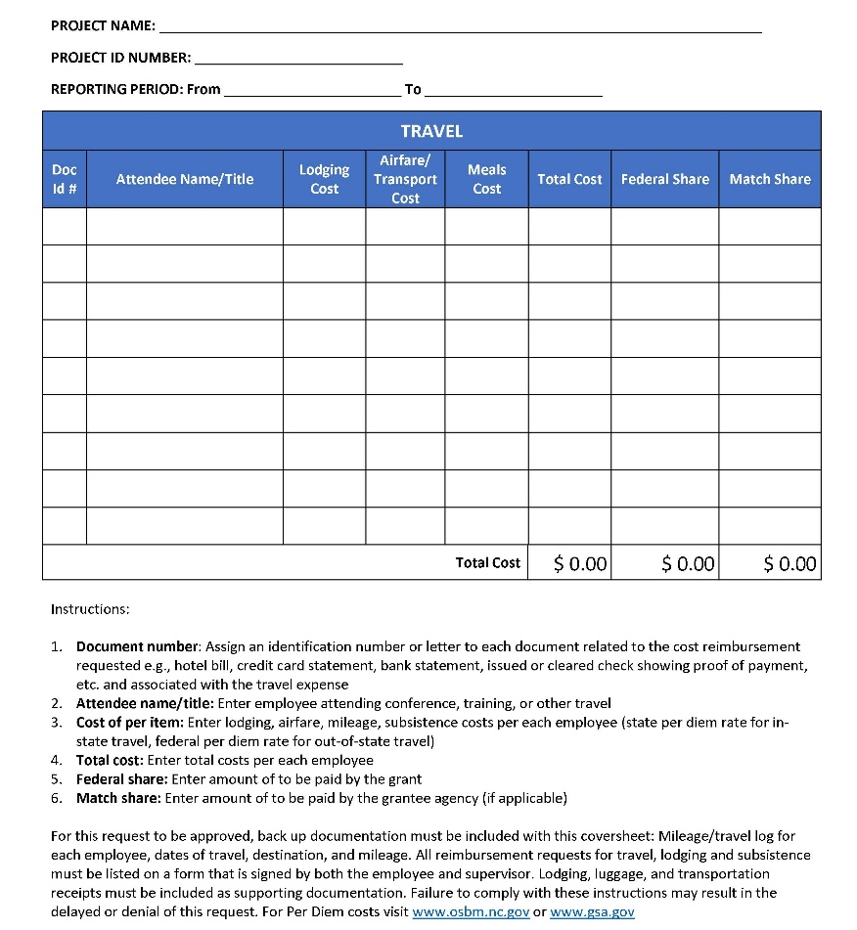
- Prior Approval for Out-of-State Travel form
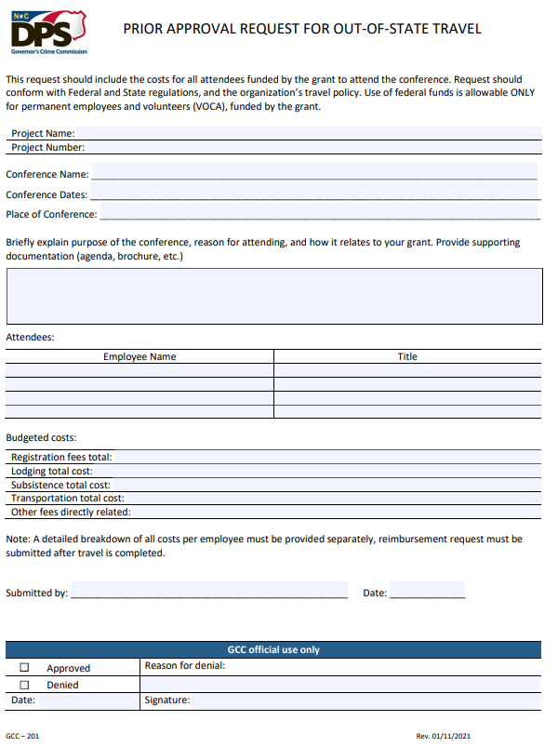
- Conference agenda, invoice, and proof of payment
- Lodging invoices and proof of payment
- Transportation invoices and proof of payment
- Meal receipts – limited to the daily per diem maximum

COST PRINCIPLES AND ADJUSTMENTS

Cost Principles
The objective of cost principles is to provide, to the extent applicable, all organizations with a similar way of doing similar work with the federal government following the same rules and procedures; to increase efficiency, reduce administrative burden, and strengthen oversight. See 2 CFR 200, Subpart E.

For a cost to be approved, the cost must be Allowable, Allocable, Reasonable, and Necessary, these are the general criteria to follow when planning budgets, budget adjustments, and requesting reimbursement requests.

An allowable cost is one that meets the criteria for authorized expenditures and meets federal standards of allowability.

A cost is allocable to an award if the goods or services involved are chargeable or assignable to the award or cost objective. Note that to be allocable to an award, a cost must either be incurred specifically for or must benefit that award, and the cost is necessary to the overall operation of the organization and is assignable in part to the award.

A cost is considered reasonable if, in its nature and amount, it does not exceed that which would be incurred by a prudent person under the circumstances prevailing at the time the decision was made to incur the cost.

Direct and Indirect Costs

Direct Costs
Generally, if a cost can be identified specifically with a cost objective, such as a grant or project, service, or other activity of an organization, it is a direct cost. If a cost has been incurred for common or joint objectives of an organization and cannot be readily identified with a cost objective or project, it is an indirect cost. Simply stated direct costs are specific to a project and indirect costs are the costs of doing business.

Direct costs are those costs that can be identified specifically with, or directly assigned to, a federal award relatively easily, with a high degree of accuracy.

Typically, direct costs may include:
- Salaries and benefits of certain employees engaged in work under the award
- Travel of certain employees directly related to the federal award
- Materials and supplies used specifically to accomplish the federal award purpose

Indirect Costs
Indirect costs are costs incurred for a common or joint purpose benefitting more than one cost objective. They are not readily assignable to the cost objectives specifically benefitted without effort disproportionate to the results achieved. These costs, though not readily assignable to an award, are necessary for both the operation of the subrecipient and to the performance of the award.

Examples of costs frequently treated as indirect costs include:
- Facility or building maintenance
- Telephone and internet expenses
- General supplies
- Depreciation
- Rental costs and leases
- Salaries and benefits of certain employees (those whose work benefits the entire organization)

A subrecipient may negotiate an "indirect cost" rate with its cognizant federal agency to facilitate the equitable allocation of indirect costs to federal awards. Generally, the rate is determined by the ratio of the total "indirect" costs of an organization (grouped together into an "indirect cost pool") to some equitable "direct" cost base. A subrecipient must be permitted to charge its negotiated indirect cost rate to each of its federal awards if the rate remains current, though certain exceptions are permitted by law; some grants may not allow indirect costs. In many cases, the cognizant agency for indirect costs may approve, upon request, a one-time extension of a current (unexpired) negotiated indirect cost rate, for up to four years.

The indirect cost rate is a ratio or percentage of an organization’s total indirect costs to its direct cost base.

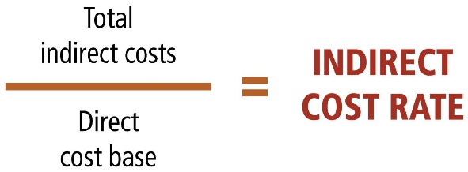

Subrecipients who have never negotiated an indirect cost rate may elect to use the 10% de minimis rate of modified total direct costs. This rate may be used indefinitely, or until an indirect cost rate can be negotiated with a cognizant federal agency.

Adjustments
Grant Adjustments occur whenever any terms or conditions mutually agreed upon in the grant agreement need to be adjusted during the grant’s period of performance. In fact, a grant adjustment changes the Grant Agreement between your organization and GCC after the initial grant agreement has been signed. All grant adjustments must be within the approved project goals and programmatic scope of work of your project unless specifically approved by your GCC Grant Administrator. Requests for adjustments are evaluated on a case-by-case basis, and only adjustments intended to meet the goals of the project and the federal award will be approved.

NOTE: Certain types of project changes require prior approval by GCC. Prior approvals are necessary where extensive financial and programmatic changes in budgets and scope work would alter the grant/project from the original, approved intent. Subrecipients must contact their grant administrator before to discuss prior approvals to ensure adherence to federal regulations and GCC guidelines.

There are two types of adjustments: Budget Adjustments and Non-Budgetary adjustments.

Budgetary Adjustments
Sometimes referred to as budget modifications, budget adjustments are submitted to make financial changes to a federal award.

Purpose of Budgetary Adjustments
Grantees/ subrecipients may request adjustments/ modifications to the approved budget to reallocate funds among budget categories/ line items within the existing federal award. The originally awarded amount may not be increased by this process.

Budget adjustments can be submitted at any time throughout the life of a project up to 90 days prior to the project end date. Any budget adjustment submitted after this deadline must have reasonable justification and approval by the assigned GCC Grant Administrator. Note that no reimbursement request can be processed while there is an unapproved adjustment in the workflow process.

GCC subrecipients must initiate a prior approval process for a budget adjustment in the event of any of the following:
- For grants/ projects with budgets of more than $250,000, where changes in the budget will generate changes in the scope of work of the project, and/ or that changes the budget by more than 10% of the awarded amount (referred to as the 10% Rule) requires prior approval of the Grant Administrator, and if approved, submission of a budget adjustment in GEMS.
Example of the 10% Rule (Prior Approval Received):
Total award amount | $ 250,000
10% of the award amount | $ 25,000
Change 1 | $ 10,200
Change 2 | $ 9,450
Change 3 | $ 7,800
Total desired budget adjustment exceeds 10% of the award amount. | $ 27,450

- The adjustment affects a cost category that was not included in the previously approved budget.
- Moving funds between line items.

Budgetary Adjustment Affects Grant Indirect Cost Awards
For grants having an effective indirect cost rate and associated budget line may be affected by a budgetary adjustment. Budget lines added, deleted, or edited will receive the same direct cost basis review as occurred during the grant application phase. The results of the cost basis review may result in the following:
- Increase in grant Federal share. Any potential increase in funds must be reviewed by your grant’s planner. An increase in funds cannot be guaranteed, and if disapproved may cause the adjustment to be modified or rejected.
- Decrease in grant Federal share. Direct-basis budget lines transferred to surplus will lessen the amount of grant indirect funds proportionately.
- No effect on Federal share.

Non-budgetary Adjustments
Non-budgetary adjustments (NBAs) are submitted to make non-financial changes to a federal award. Non-Budgetary Adjustments are used for:
- Grant scope changes.
- Personnel adjustments.
- Grant period extensions.

Non-Budgetary adjustments can be submitted at any time. However non-budgetary adjustments requested before 90 days of the project end date must have reasonable justification and approval by the assigned GCC Grant Administrator.

Grant Period Extensions
Subrecipients may submit a one-time post-award request for an extension of up to 90 days and possibly up to 12 months on their project. A no-cost extension (NCE) is made to ensure the completion of the originally approved project or to permit an orderly phase-out of a project that will not receive continuation support.

Extensions involve changes to the project end date. The following guidelines apply:
- All requests for extensions require prior approval from GCC.
- Extensions generally do not exceed 3 months, but projects may be extended up to 12 months.
- Two awards cannot overlap if they are funded under the same priority, recipient grant, or for the same purpose. For example, a current Sexual Assault Basic Services project cannot be extended if it overlaps a continuing Sexual Assault Basic Services project that will begin during the extension period.
- A request for an extension of the project period must be justified by circumstances that adversely affected the subrecipient’s ability to perform some aspect of the project or to fully expend funds during the period of performance.
- Requests for retroactive extensions of project periods will not be considered.
Extensions will not be made to spend down remaining funds as remaining funds from year one. Requests to extend for the purposes of spending down year two funds must contain a statement as to why year two activities did not spend down, available funds, and a plan on how the funds will be spent down within the extension period.

Grant Scope and Programmatic Changes
GCC subrecipients must initiate an approval process for a non-budgetary adjustment in the event of any one or a combination of, but not limited to, the following:
- Changing programmatic activities.
- Changing the length of time to complete the project.
- Changing the goals/ purpose of the project.
- Changes in scope involve making one or more adjustments to the cost, budget, timeline, and/or other features of the project to the extent that the changes deviate from the budget, goals, and objectives of the award. When in doubt about whether a needed change involves a change in scope, contact the GCC Grant Administrator.
NOTE: Prior approval is required for a change in scope adjustment. Subrecipients must contact their grant administrator before to discuss prior approvals to ensure adherence to federal regulations and GCC guidelines.

Personnel Changes

Persons Affected by Personnel Adjustments
Subrecipients must receive pre-approval from GCC whenever there is a change concerning a “key person specified in the application or Federal Award” (see 2 CFR 200.308 (c)(2). This requirement affects, at a minimum, the following persons:
- Authorizing Official
- Project Director (see also 2 CFR 200.308 (c)(3)
- Key persons mentioned in the grant application (examples)
  - Executive Directors of non-profit agencies
  - Changes in positions funded all, or in part, by the grant

Changing the Authorizing Official or Project Director
Changes to the Authorizing Official or Project Officer are accomplished the same way.
- Pre-authorization. Required before any further action may be taken.
  - The approval is requested in writing by the (new) Authorizing Official using agency letterhead.
  - The request asks permission to change the appropriate grant official along with a short justification of why the change is needed.
  - Authorizing Official signs the request.
  - If the request involves the Authorizing Official, the request must be countersigned by the polity clerk or non-profit secretary. The clerk/secretary must confirm under seal the authorizing official succeeded to their position as of [date].
  - The approval request is sent to the GCC Grants Administrator for approval. If approved, the GA will respond with the approval and next necessary steps.
- Post-approval Actions, Incoming Official. Steps taken to provision new grant official in GEMS, summarized as follows:
  - Obtain an NCID issued by the agency/non-profit.
  - Incoming official will log into GEMS and link their profile with their agency follow graphics.

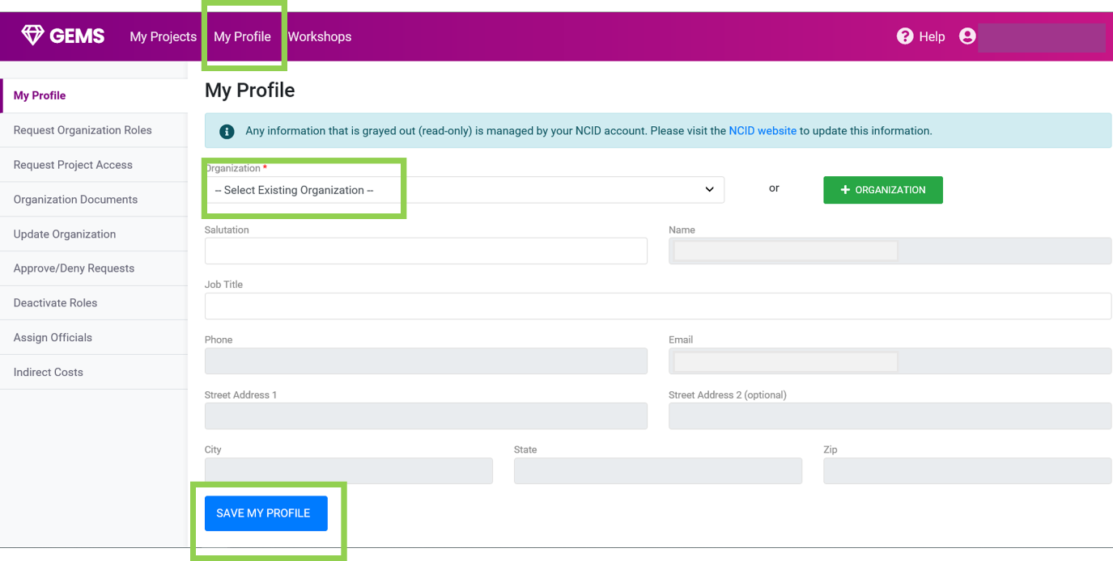

  - [Authorizing Official ONLY] Navigate using left-side menu to “Request Organization Roles,” and select “Authorizing Official” and provide a justification statement.

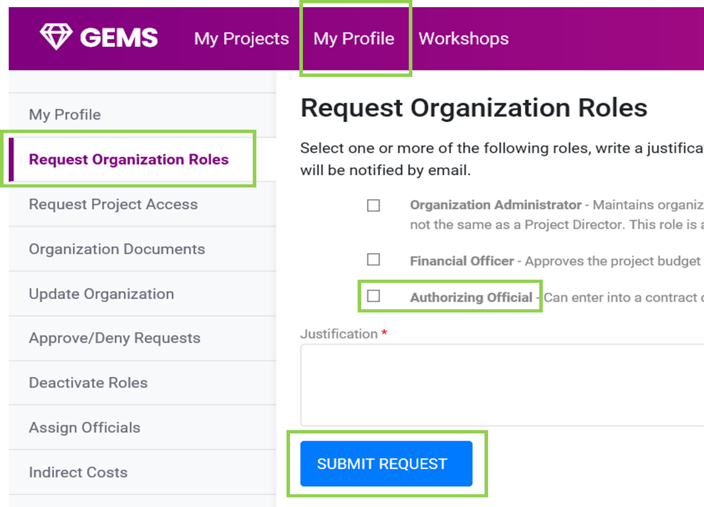

  - [Authorizing Official, Project Director] Contact agency Organization Administrator and have themselves assigned to project(s) for which they will be administrating official or project director. The AO will complete the following page for each project affected.

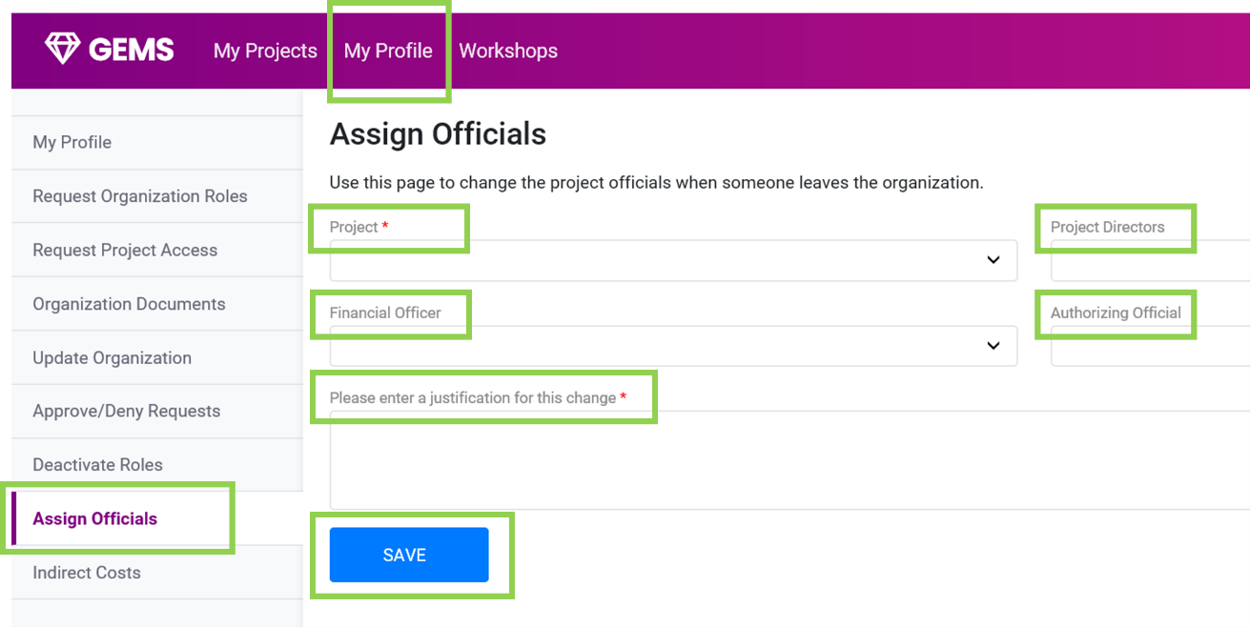

Changes to Positions Specified in the Grant Application
Changes in expense lines funding salaries also require GCC pre-approval. The method for securing this pre-approval is through either a budgetary OR non-budgetary adjustment, depending on the situation.

Adding New or Deleting Existing Positions
- Open a new budget adjustment in GEMS.
- [NEW POSITIONS] Use this option to add a new position.
  - Using the “+ Budget Line” button to open the interface
  - Add the pertinent information for the new personnel position, including the name of the person who will be paid with these funds.
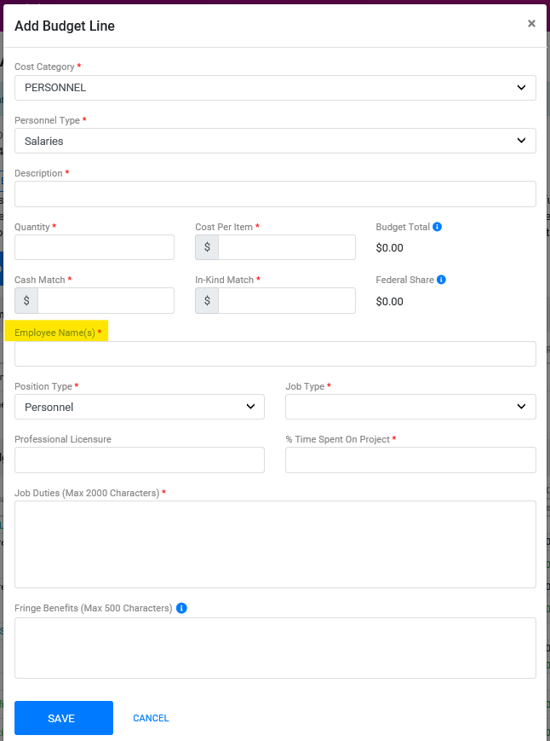

- [DELETING POSITION] Use this option to indicate the departure of an individual who will not be replaced.
  - In the previously opened budget adjustment, find the personnel line you wish to finish with early.
  - At the far right of the line to be halted, find, and press the “freeze” button. This will prevent any further reimbursements from this line and move any unspent funds to Surplus.

Updating an Existing Personnel Line
Updating an existing personnel line is accomplished by a non-budgetary adjustment known as a “Project Personnel Adjustment”.
An off the shelf Personnel Adjustment will show you the job information for the existing personnel entries for the grant. Press the “edit” button for the line you wish to modify and proceed.
Note: If you have not completed paying out the original employee, add the new name and leave the original until their payrolls are reimbursed.

MONITORING & UTILIZATION

6 Monitoring Overview
Governor’s Crime Commission is responsible for the oversight of grant- supported activities and operations. Subrecipients are monitored at least annually and must submit quarterly PMT reports, as well as Federal fiscal year-end performance report, according to the terms and conditions of the Federal award.

What gets Monitored:
- Financial Reporting and systems that are aligned with 2 C.F.R. 200.328 for financial reporting.
- Program Performance reporting is aligned with 2 C.F.R. 200.329 which relates to monitoring and reporting program performance.
- Compliance requirements are identified to the subrecipient at the time of the award
- and subrecipient activities are monitored throughout the period of performance of the grant.

Monitoring Process
Some of the mechanisms GCC uses to monitor subrecipient activities throughout the period of performance include regular communication with subrecipients, appropriate inquiries concerning program activities; performing subrecipient site visits to examine financial and programmatic records and observe operations; and reviewing detailed financial and program data and information submitted by the subrecipient.

Desk Review
The financial monitoring desk review includes an analysis of award activities to date and evaluates:
- Compliance with reporting requirements.
- Excess cash analysis (reimbursements compared to expenditures reported).

During a desk review, the award subrecipient may be asked to provide a general ledger. Should deficiencies be identified during either an onsite review or desk review, or if there have been deviations from the approved budget without prior approval from the Governor’s Crime Commission, Grants Management staff will work with the recipient to provide technical assistance.

On-Site Visits
GCC is required to perform site visits on all VOCA, VAWA, and JJ grants. GCC’s Grants Management Staff will review the following procedures, policies, and documents during an onsite monitoring and technical assistance visit:
- Internal controls
- Accounting system
- Organizational policies and procedures, including accounting procedures
- Federal Financial Reports
- Compliance with reporting requirements and/or award special conditions
- Risk Matrix

The Grant Administrator will compare actual expenditures with award objectives and the approved budget to determine if the subrecipient is spending the funding according to the purpose of the award. The Grant Administrator may also provide technical assistance to the subrecipient during the visit.

On-site Visit Process and Requirements

Entrance Interview
Required to attend the interview: the Executive Director, Project Director, and CFO/Director of Finance.

During the visit, the program is discussed, a tour conducted, and a batch review of cost reports the agency has submitted (this will include all original supporting documentation for reimbursement requests). This will also be an opportunity to discuss concerns/issues.

Organization/Financial/Program Review
- Organizational Policies and Procedures
  - List of executive, management, supervisor, and clerical staff being charged to the grant project
  - Lease/Rental Agreements (for any facility billed to GCC)
  - Organization Chart
  - Travel policy, Record Retention policy, Procurement policy (bids, sole source)
  - Conflict of Interest Policy

- Finance
  - Accounting System
  - Chart of Accounts (including sub-accounts)
  - Accounting Policy and Procedures Manual (documentation of internal controls)
  - Bank Reconciliations (with approval signatures)
  - General Ledger – Program Specific
  - Cost Allocation Plan (related to GCC programs along with worksheets for allocating costs)
  - Most current audit/audited financials completed by an outside auditing firm (including A-133 Single Audit)
  - List of match sources for the program (including volunteers)
  - Payroll tax returns (including proof of payment)

- Program
  - Walk through of intake process
  - Determination of participant eligibility
  - Walk through of the follow-up process once clients have completed the program
  - The system being utilized to collect client-level data (HMIS, etc.)
  - If applicable – finalized contract for services that have been subcontracted that ensures they are not debarred from receiving federal funds
  - If applicable - List of equipment purchased by the grant (include location, condition, if it was disposed of, the sale price/fair market value)
  - Original timesheets with signatures

Exit Interview
Upon completion, the Grant Administrator will discuss their initial assessment of the site visit. This may include any issues/concerns, corrective actions, or recommendations.

Use of Funds

Appropriate Usage of Funds
Award agreements create a legally binding obligation for the subrecipient to use funds in a certain way and to comply with various certifications, assurances, applicable federal law, rules, and regulations. By signing the award agreements, the subrecipient is accepting responsibility for the proper oversight and administration of the grant, in compliance with all applicable rules, regulations, and statutes.

Award subrecipients should pay close attention to the following issues to better address this area:
- Accounting Systems. Subrecipients must establish and maintain an adequate accounting system and be able to provide sufficient documentation to prove that all reimbursement is reasonable, allowable, documented, allocable, and provided with regular consistent treatment. A subrecipient's accounting system must be able to track the specific use of each source of revenue to avoid commingling issues. In some cases, all reimbursements of expenses can be called into question if the commingling of separate grant revenues and expenses makes a proper accounting for federal award funds impossible.
- Expenditures per Grant Award. Funds must be used for the purposes identified in the grant solicitation and award documents —they cannot be unilaterally re-directed for another use. Certain uses of award funds are categorically prohibited or restricted, such as lobbying or purchasing land and armored vehicles. Recipients should be familiar with these restrictions to properly oversee or manage award funds.
- Record Keeping. Subrecipients should carefully review their accounting procedures and other internal controls related to indirect costs, matching funds, and employee time and effort records — where errors can occur.

Timely Usage of Funds (Utilization)
GCC intends to encourage subrecipients to accurately program, monitor, and deliver projects in a timely manner. The utilization of funds should coincide with the grant period. If you have a two-year grant, funds expended in the first year should be at 50 percent of the total budget. Utilization of the grant funds is monitored quarterly by your Grant Administrator and if necessary, discussed with your Project Director. The following is a table that gives you an idea of the usage of funds.

Keep in mind, that any unused funds from year one will be reverted to GCC as will any unused funds from year two.

Year 1 | Overall Percentage
1st Quarter | 12.5%
2nd Quarter | 25%
3rd Quarter | 37.5%
4th Quarter | 50%
Year 2 | Overall Percentage
1st Quarter | 62.5%
2nd Quarter | 75%
3rd Quarter | 87.5%
4th Quarter | 100%

Monthly Reimbursements
Monthly Reimbursements should be submitted in a timely manner. Reimbursements submitted should be for the prior month. If possible and under normal circumstances, there should not be more than one reimbursement submitted monthly. Reimbursement requests submitted and approved by Friday at 12:00 pm will generally be paid on the following Tuesday.

NOTE: Monthly reimbursements may be placed on hold due to reports not being submitted in a timely matter or the expiration of certain information.. Monthly reimbursements must include the necessary documentation for approval. For details, refer to the sections on Reimbursement Documentation.

Risk

Risk Assessment
Grant risk is determined in two ways. If the subrecipient is brand new, GCC will conduct a risk assessment prior to the opening of a grant. Risk determined through a risk assessment is assigned by the planner. Subsequent risk measurements are by Grants Management using a matrix-based evaluation tool.

Grants may be evaluated as higher risk or lower risk; the assessment of risk is used to determine the monitoring approach for a grant. Generally, a subrecipient that lacks experience in implementing federal awards or with implementing similar grants may require closer monitoring.

Closer monitoring might also be warranted if the subrecipient has a history of non-compliance as either a recipient or subrecipient, new personnel, or new or substantially changed systems.

Each grant will be assigned a risk rating. Some considerations that will impact risk rating are:
- Subrecipients implementing programs with complex compliance requirements may be at a higher risk for non-compliance.
- A pass-through entity passing through a large portion of the federal award (whether in terms of dollars passed through or in terms of the share of accountability for implementing approved activities within the overall level of effort—or both) may give rise to the need for a careful and deliberate approach to subrecipient monitoring.
- Larger dollar awards may have more risk potential.

Risk Ratings

Low Risk
Subrecipient is knowledgeable of grants and submits all documentation on time and accurately. The program is running according to applicable standards and funds are being utilized at the expected rate.

Medium Risk
Subrecipient is late on reports, submitting reimbursements sporadically or rarely, lack of communication on subrecipient side, frequently missing documents. Requires closer monitoring of projects and assistance from the Grant Administrator to bring them into compliance.

High Risk
Project is not functioning according to application, reimbursements are not being submitted, missing reports/frequently late, lack of spending funds, subrecipient needs excessive training to come into compliance.

Holds Affecting your Grant
Holds on grants may originate from conditions at either the organization or the project levels. Generally, holds will affect all grants in an organization. Therefore, it is imperative that both organization triggers and grant triggers for all grants must be monitored for compliance. Multiple holds may be in place at any given time and all hold conditions must be remediated before reimbursement requests may be submitted or paid.

Organization Level Holds

Suspension of Funding List (SOFL)
- Subrecipient appears on the State Suspension of Funding List.

NOTE: This hold can only be released once the subrecipient has been removed from the SOFL list by the Office of State Budget Management.

Grant Level Holds
Grant level holds are placed with reports that are not submitted by the date due as noted below. Late reports
- Juvenile Justice Report past due
- Annual Project Progress Report past due
- Quarterly PMT Report past due – SEE NOTES:
  - The report is created and registered with https://ovcpmt.ojp.gov AND must be submitted in GEMS as well as reviewed and approved by your grant’s administrator.
  - PMT reports are required by more than one Federal Grant. Each may have different submission criteria.
- VAWA Annual Progress Report is past due

REPORTING
Recipients are required to submit both financial reports and performance reports (also called progress reports). These reports describe the usage of funds, a comparison of actual accomplishments to the grant’s objectives/goals, and other pertinent information. Grant award documents may also include special requirements specific to the individual award.

Progress and performance reports provide information relevant to the performance and activities of a plan, program, or project. Depending on the awarding agency and the specific grant program, progress/program reports may be submitted annually, semi-annually, or quarterly. Information on due dates is discussed by report type, below.

GRANTS MUST BE CURRENT IN ALL REPORTS IN ORDER TO HAVE REIMBURSEMENTS PROCESSED FOR PAYMENT.

Audit (Financial) Reporting
North Carolina state law (G.S. 143C-6-22; 143-6-23) and the North Carolina Administrative Code (09 NCAC 03M) establish annual reporting requirements for entities receiving State or Federal pass-through funds through a state agency. These reports are intended to describe how the funds received were used. Reporting instructions and associated forms are located here: https://www.ncdps.gov/about-dps/boards-and-commissions/governors-crime-commission/grant-forms#post-award

Level I (Less than $25,000)
A grantee receiving less than $25,000 (combined) in State or Federal pass-through funds must submit:
- Certification Form
- State Grants Compliance Reporting for Receipts of Less than $25,000
- Level I form and reporting instructions are available on the GCC website forms page.
https://www.ncdps.gov/about-dps/boards-and-commissions/governors-crime-commission/grant-forms#post-award

Level II ($25,000 – 499,999)
A grantee that receives between $25,000 - $499,999 (combined) in State or Federal pass-through funding must submit:
- Certification Form
- State Grants Compliance Reporting for Receipts of $25,000 or More
- Schedule of Receipts and Expenditures
- Program Activities and Accomplishments Reports
- Level II form and reporting instructions are available on the GCC website forms page.
https://www.ncdps.gov/about-dps/boards-and-commissions/governors-crime-commission/grant-forms#post-award

Level III ($500,000 - $749,999)
A grantee that receives a combined $500,000 or more in North Carolina State funding or Federal funding passed through a State Agency must submit:
- Certification Form
- State Grants Compliance Reporting for Receipts of $25,000 or More
- Program Activities and Accomplishments Reports
- Submit within nine months of the grantee's fiscal year-end:
  - Submit to DPS Internal Audit a single audit prepared and completed in accordance with Generally Accepted Government Auditing Standards.
  - Level III form and reporting instructions is available on the GCC website forms page.
https://www.ncdps.gov/about-dps/boards-and-commissions/governors-crime-commission/grant-forms#post-award

Level III+, ($750,000+)
A grantee that receives a combined $750,000 or more in funding from all Federal funding sources, even those passed through a state agency must submit:
- Certification Form
- State Grants Compliance Reporting for Receipts of $25,000 or More
- Program Activities and Accomplishments Reports
- Submit within nine months of the grantee's fiscal year-end:
  - Submit to DPS Internal Audit a single audit prepared and completed in accordance with Generally Accepted Government Auditing Standards.
  - Post the single audit to the Federal Audit Clearinghouse (https://harvester.census.gov/facweb/).
  - Make copies of the single audit available to the public.
- Level III form and reporting instructions are available on the GCC website forms page.
https://www.ncdps.gov/about-dps/boards-and-commissions/governors-crime-commission/grant-forms#post-award

VOCA Subgrant Award Report
The VOCA Subgrant Award Report (SAR) is used to categorize the award’s purpose, the primary use of funds, grantee staffing and budgetary resources, and services the grantee provides.

VOCA SAR Report Process
The following steps will be completed for each VOCA grant after the Notice of Grant Implementation is completed.
- This must be completed for each VOCA-funded project.
- Due within 30 days of the implementation of a project.
- The Initial Subgrant Award Report (ISAR) is completed by the Subrecipient and entered directly in GEMS.
- The Grant Administrator will enter the SAR Part 1 in OVC-PMT.
- The Subrecipient is then notified by the Grant Administrator.
- The Subrecipient must complete the SAR Part 2 in OVC-PMT to gain access to project reporting in the system.

GCC Project Progress Report
The GCC Project Progress Report is the comprehensive report on how a project has performed relative to the objectives and goals submitted and in effect when the grant is awarded.

Progress Report Coverage Periods
The progress report covers a Federal fiscal year, or part thereof (Oct 1 20XX – 30 Sep 20YY). Depending on the period of performance for your grant, you may have one or more reports to complete. Be aware of which report you are filing.

Progress Report Due Dates
The progress report is due 30 days after the end of the reporting period. Examples:
- Normal deadline: Reporting period ends Sep 30 – report due Oct 30.
- Project ends prior to the end of Federal fiscal year: Project ends Jun 30 -- report due Jul 30.
- Early reporting is allowed if all project activities are complete, and the final reimbursement is ready for submission.

Progress Report Process
GCC progress reports are completed in GEMS.
- Log into GEMS, select the appropriate grant.
- Navigate to Project Progress Report using the left menu.
- Select the appropriate report to complete and respond to the questions in each tab. Answer content must be relevant to the subject of the question.
Example:
  - The objective is to reduce occurrences of speeding in a given area by 15 percent.
  - The answer is to show a change in the number of occurrences and the percent change for the reporting period.
  - Submit to GCC when complete/finished.

Performance Management Tool (PMT) Report
Performance Measurement Tool (PMT) reports are created and first filed on the Federal Bureau of Justice Affairs (BJA), Office of Justice Programs (OJP), or Office for Victims of Crime (OVC) website, as appropriate to your grant. You should have received a login, password, and access instructions from the Federal website.
- The Project Director is the point of contact for all GEMS reporting correspondence.
- Additional project staff can be added to the PMT profile for Federal reporting purposes.
- Performance measurement data required for this reporting period must be entered using the OVC-PMT website: https://ovcpmt.ojp.gov
- Failure to report quarterly performance for each GCC-funded project in BJA/OVC-PMT and GEMS (see below) will result in a hold of all grant funds received by the subrecipient.

PMT Report Due Dates

Byrne-JAG PMT Due Dates
BJAG Report Deadline | Due Date
Q1: October - December | January 10th
Q2: January - March | April 10th
Q3: April - June | July 10th
Q4: July - September | October 10th

VOCA PMT Due Dates
VOCA Report Window | Due Date
Q1: October - December | January 30th
Q2: January - March | April 30th
Q3: April - June | July 30th
Q4: July - September | October 30th

Submitting a PMT Report
Submitting a PMT report is a two-stage process. The first stage involves signing in your profile on the BJA/OVC website and completing the PMT report itself using the instructions shown on the Federal site.

Upon submission of your report in the PMT system, you must:
- Save a PDF copy from BJA-PMT/OVC-PMT and submit it to GCC as an upload to the project documents in GEMS.
- Log into GEMS and navigate to PMT Reports using the left menu.
- At the PMT Reports window, there will be a list of reporting periods for which reports are necessary.
- Select the appropriate reporting period and upload the PDF report retrieved from the BJA-PMT/OVC-PMT website.

NOTE: The reporting periods for both the Federal report sample and the chosen GEMS reporting period must match, otherwise, your report will be returned for correction.

Federal PMT Site Technical Difficulties
The staff at the Governor’s Crime Commission cannot address any technical issues with the website. If you are having problems with the website or system, you must contact the OVC-PMT Help Desk at ovcpmt@usdoj.gov or 1-844-884-2503.

CJA & JJ Federal Reports
Grants funded by the Children’s Justice Act (CJA) and Juvenile Justice Delinquency Prevention (JJ) Federal grants are required to submit through GEMS programmatic JJ Mid=Year and JJ Final reports. The number of both mid-year and final reports will be dependent on the start and end dates of your grant.

CJA & JJ Report Periods and Due Dates
The reporting periods and due dates vary based on the Federal funding source for your award, which can be found on your Grant Award document.

Grant Source | Report Name | Activity Period | Due to GCC
Juvenile Justice Delinquency Prevention | JJ Mid-Year | October – March | April 15
Juvenile Justice Delinquency Prevention | JJ Final | April - September | October 15
JJDP PREA Reallocation | JJ Mid-Year | January – June | July 15
JJDP PREA Reallocation | JJ Final | July – December | January 15
Children’s Justice Act | JJ Mid-Year | October – March | April 30
Children’s Justice Act | JJ Final | April - September | October 30

VAWA Federal Progress Reports
VAWA progress reports are by calendar year. While GCC grants are one year in length, they will run through two reporting periods and associated deadlines as shown below:
- Oct 1 – Dec 31 (Project start – end of year)
Due Jan 31 of the following year
- Jan 1 – Sep 30
Due 30 days after the end date (Oct 30)

CLOSING AWARDS
Per 2 CFR 200.343, closure means the process by which it is determined that all applicable administrative actions and all required work of the Federal award have been completed. All award subrecipients have 60 days after the project end date to submit all final financial, performance, or other reports required by the award. Examples of important closure milestones are:
- Mark the last reimbursement as “final” in GEMS. This prompts the grant administrator to begin the closure process.
- All match requirements are met.
- Any refunds owed to GCC are paid.
- All final reports are completed and submitted in GEMS.
- All monitoring review actions are complete.
- All unobligated funds are identified for reversion to GCC

Subrecipients should begin the closeout process as soon as the project is completed, objectives have been met, federal funds have been spent, and if applicable, required matching funds have been met. A closeout of an award can be initiated prior to the end date of the performance period.

Review of Utilized Funds

Match Requirements
Match requirements must be met by the end of the award period. Failure to meet match requirements will result in the return of funds to GCC. The amount of the return of funds will be calculated by GCC as the portion of the federal share that was reimbursed, but not properly matched. The subrecipient will be notified if a return of funds is required.

Final Reimbursement
The subrecipient needs to make sure that funds are obligated prior to the end of the award period. All contracts need to be reviewed for completion and to assure that all final invoices are received from the contractors and paid by the subrecipient. After reconciling all expenditures to revenue received, any funds due to the subrecipient need to be submitted for reimbursement from GCC no later than 60 days after the end of the performance period. The subrecipient should mark the last reimbursement as “final” in GEMS.

Return of Funds
After reconciling all expenditures to revenue received, any funds paid to the subrecipient that exceeds the amount to which the organization is finally determined to be entitled, constitutes a debt owed to GCC. GCC will contact the subrecipient, inform them of the amount owed, and assure that the repayment is received before the grant is closed out. If the funds are not returned to GCC, they will become delinquent debts, and the subrecipient risks:

- Possible ineligibility for further grant participation until all debts are paid
- High-risk designation for future awards
- Withholding or freezing of funds
- Special conditions may be placed on all the subrecipient’s other awards
- Additional collection actions

Reverted Funds
Any unused grant funds at the end of year one will be moved to surplus and reverted to GCC. Any unused funds from year two will be determined and reverted to GCC. The amount of the reversion will be noted in the subrecipient’s grant file and will be reviewed and taken into consideration in future risk assessments.

All Required Reports are Submitted
The subrecipient needs to make sure that all final financial, programmatic, and other reports that were required by the terms and conditions of the award have been submitted to GCC within 60 days after the end date of the performance period. GCC will review these reports to ensure compliance with all award terms and conditions, the project goals have been met, and the grant funds have been spent appropriately.

Disposition of Equipment and Unused Supplies
At the end of the award period, the subrecipient is responsible for the disposition of equipment and unused supplies. If the total amount of the unused supplies is greater than $5,000 or the value of the equipment is greater than $5,000, GCC will determine the method of disposition of the equipment and/or the unused supplies. If the grant-funded program continues after the end of the award period, the equipment can continue to be used. If the program no longer continues to operate, the subrecipient can request to transfer the equipment to other programs that are currently or previously supported by federal funds. GCC will determine the method of disposition and instruct the subrecipient accordingly.

Administrative Closure
Under certain conditions, GCC reserves the right to initiate an Administrative Closure prior to the project end date. In this case, a notice will be sent to the subrecipient.

If the award subrecipient does not initiate the closeout within 60 days of the project period end date, GCC will begin an administrative closeout process without consent. During the administrative closure, GCC will perform a financial reconciliation. If the reconciliation process reveals that refunds are due to GCC, the recipient will be notified with a request for the return of funds. This process includes the review of the match portion of the total budget. If the match is not met and if funds are already reimbursed, the subrecipient may have to pay back a portion of the Federal Funds. The amount of the funds that need to be returned will be calculated by GCC and the subrecipient will be notified.

Post-Closeout and Continuing Responsibilities

GCC Recovery of Funds Allowed After Closure
Per 2 CFR 200.344, the closeout does not affect GCC’s right to disallow costs, process refunds, make corrections, or recover funds after a later review or audit of the award.

Federal Documentation Retention Rules
All grant award documentation is to be kept with the subrecipient for three years after the final expenditure report is submitted. The documentation includes, but is not limited to, financial and statistical records, detailed general ledger reports, progress and performance reports, reimbursements with supporting documentation, contracts, personnel and payroll records, time and activity reports, and all other documents that are pertinent to the award. The retention period could extend past three years if there is pending litigation, claims, or an audit of the award. All documentation must be retained until after these issues have been resolved and any final actions are taken. GCC should be kept informed of who is the custodian of the records and documentation. GCC, the Department of Justice, and the Comptroller of the United States have the right to access all documentation for as long as it is retained with the subrecipient.

State Subrecipient Additional Document Retention Rules
In addition to the documentation requirements stated in 2CFR200.343, State Subrecipients are required by 13 NCAC 14B .0610 to use the following retention periods:
- Employment records: five years
- Medical records: seven years

OTHER RESOURCES

Acronyms
ACRONYM | MEANING
ADC | ALLOWABLE DIRECT COSTS
ALA | ANTI-LOBBYING ACT
AIC | ALLOWABLE INDIRECT COSTS
BJA | BUREAU OF JUSTICE ASSISTANCE
CAS | COST ACCOUNTING STANDARDS
CAP | CORRECTIVE ACTION PLAN
CFDA | CATALOG OF FEDERAL DOMESTIC ASSISTANCE
CFR | CODE OF FEDERAL REGULATIONS
CJI | CRIMINAL JUSTICE IMPROVEMENT
COA | CHART OF ACCOUNTS
COG | COUNCILS OF GOVERNMENTS
COSO | COMMITTEE OF SPONSORING ORGANIZATIONS OF THE TREADWAY COMMISSION
CRM | CUSTOMER RELATIONSHIP MANAGEMENT
CVS | CRIME VICTIM’S SERVICES
DOJ | DEPARTMENT OF JUSTICE
DPS | DEPARTMENT OF PUBLIC SAFETY
DHHS | DEPARTMENT OF HEALTH AND HUMAN SERVICES
ERISA | EMPLOYEE RETIREMENT INCOME SECURITY ACT OF 1974
F&A | FACILITIES AND ADMINISTRATION
FAC | FEDERAL AUDIT CLEARINGHOUSE
FAIN | FEDERAL AWARD IDENTIFICATION NUMBER
FAPIIS | FEDERAL AWARDEE PERFORMANCE AND INTEGRITY INFORMATION SYSTEM
FAR | FEDERAL ACQUISITION REGULATION
FCM | FINANCIAL CLEARANCE MEMORANDUM
FFATA | FEDERAL FUNDING ACCOUNTABILITY AND TRANSPARENCY ACT
FFR | FEDERAL FINANCIAL REPORT
FICA | FEDERAL INSURANCE CONTRIBUTIONS ACT
FMV | FAIR MARKET VALUE
FOIA | FREEDOM OF INFORMATION ACT
EPOC | FINANCIAL POINT OF CONTACT
FR | FEDERAL REGISTER
FTE | FULL-TIME EQUIVALENT
FTR | FEDERAL TRAVEL REGULATION
GAAP | GENERALLY ACCEPTED ACCOUNTING PRINCIPLES
GAGAS | GENERALLY ACCEPTED GOVERNMENT AUDITING STANDARDS
GAN | GRANT ADJUSTMENT NOTICE
GAO | GOVERNMENT ACCOUNTABILITY OFFICE
GCC | GOVERNOR’S CRIME COMMISSION
GEMS | GRANT ENTERPRISE MANAGEMENT SYSTEM
GPRA | GOVERNMENT PERFORMANCE AND RESULTS ACT
GPRS | GRANT PAYMENT REQUEST SYSTEM
GSA | GENERAL SERVICES ADMINISTRATION
IHE | INSTITUTIONS OF HIGHER EDUCATION
IRC | INTERNAL REVENUE CODE
ISDEAA | INDIAN SELF-DETERMINATION AND EDUCATION AND ASSISTANCE ACT
JAG | (BRYNE) JUSTICE ASSISTANCE GRANT
JJDPA | JUVENILE JUSTICE AND DELIQUENCY PREVENTION ACT
JJP | JUVENILE JUSTICE PLANNING
JJRA | JUVENILE JUSTICE REFORM ACT
MTC | MODIFIED TOTAL COST
MTCD | MODIFIED TOTAL DIRECT COST
M&IE | MEALS AND INCIDENTAL EXPENSES
NCDPS | NORTH CAROLINA DEPARTMENT OF PUBLIC SAFETY
NDAA | NATIONAL DEFENSE AUTHORIZATION ACT
NFE | NON-FEDERAL ENTITY
NIJ | NATIONAL INSTITUTE OF JUSTICE
OCFO | OFFICE OF THE CHIEF FINANCIAL OFFICER
OCR | OFFICE FOR CIVIL RIGHTS (OF THE OFFICE OF JUSTICE PROGRAMS)
OIG | OFFICE OF INSPECTOR GENERAL
OJP | OFFICE OF JUSTICE PROGRAMS
OJJDP | OFFICE OF JUVENILE JUSTICE DELINQUENCY PREVENTION
OMB | OFFICE OF MANAGEMENT AND BUDGET
OVC | OFFICE FOR VICTIMS OF CRIME
OVW | OFFICE FOR VIOLENCE AGAINST WOMEN
PAN | PAYEE ACCOUNT NUMBER
PII | PERSONALLY IDENTIFIABLE INFORMATION
PMS | PAYMENT MANAGEMENT SYSTEM
PMT | PERFORMANCE MEASUREMENT TOOL
POP | PERIOD OF PERFORMANCE
PPOC | PROGRAMMATIC POINT OF CONTACT
PRPH | POST-RETIREMENT HEALTH PLANS
PTE | PASS-THROUGH ENTITY
REUI | RELATIVE ENERGY USAGE INDEX
SAA | STATE AWARDING AGENCY
SAM | SYSTEM FOR AWARD MANAGEMENT (ACCESSIBLE AT HTTPS://WWW.SAM.GOV)
SASP | SEXUAL ASSAULT SERVICES PROGRAM
SF-SAC | STANDARD FORM-SINGLE AUDIT COMPONENT
SPOC | SINGLE POINT OF CONTACT
TANF | TEMPORARY ASSISTANCE FOR NEEDY FAMILIES
TFM | TREASURY FINANCIAL MANUAL
U.S.C. | UNITED STATES CODE
USDHHS | UNITED STATES DEPARTMENT OF HEALTH AND HUMAN SERVICES
VAT | VALUE ADDED TAX
VAWA | VIOLENCE AGAINST WOMEN ACT
VOCA | VICTIMS OF CRIME ACT

Links
Name | Link | Type of Information Available
Electronic Code of Federal Regulations | https://www.ecfr.gov/ | - Code of Federal Regulations  - Details on 2 CFR.200
Federal Audit Clearinghouse | https://harvester.census.gov/facweb/ | - Portal for transmitting audit packages to Federal Government
NC Governor’s Crime Commission | https://www.ncdps.gov/gcc/ | - Commission Overview  - Contact Information  - GCC Policies  - Grant Forms & Sample Documents
US Department of Justice | https://www.justice.gov/grants | - Federal Grant Program and Agency Details  - Information on Funding Opportunities
US Department of Justice | https://ovcpmt.ojp.gov | - Performance Management Platform  - PMT Report Portal
NC Governor’s Crime Commission | https://www.ncdps.gov/node/7181#post-award | - Post–Award Grant Forms  - Expense reimbursement cover pages  - Time and Activity forms  - State grant compliance reporting forms

