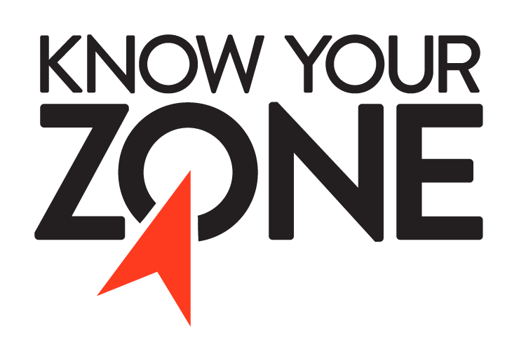
Know Your Zone – North Carolina
Talking Points
North Carolina Know Your Zone is a tiered evacuation system that highlights areas most vulnerable to impacts from hurricanes, tropical storms, and other hazards. These pre-determined evacuation zones in twenty-one of North Carolina’s eastern counties simplify and improve evacuation execution in the event of an approaching tropical system.
The goal of Know Your Zone is to educate coastal residents about the new evacuation zones so that all residents know what zone they live in and know to look/listen for that zone when a storm comes and evacuations are ordered.
The Zones
The zones for coastal counties were developed using storm surge modeling from National Hurricane Center’s Hurricane Evacuation Study as a starting point. County officials were able to use data from the NC Hurricane Evacuation Study maps as well as previous experience in ordering coastal evacuations to draft the evacuation zones for their county. County officials were also able to determine how many zones were needed based on the population and potential for inundation. Some counties only have 1 zone where others have up to 5 zones in order to evacuate as efficiently as possible without over evacuating.
Inland counties that are not susceptible to storm surge developed evacuation zones based on river flooding.
Evacuation zones highlight areas most at risk to storm surge and flooding. While many first think of wind when they here ‘hurricane’, it is the impacts from water that are the greatest threat to life and property.
Website
KnowYourZone.nc.gov contains all the program’s information, and an online address lookup for residents in coastal counties to know their zone. Website elements also include the North Carolina Hurricane Guide, county-by-county zone maps, a downloadable digital toolkit with social media graphics, and other materials local governments can use to promote the program and educate residents. The FAQ is intended to help users better understand the initiative.
The website has also been translated to Spanish and can be found at ncdps.gov/es/conozca-su-zona
Toolkit
These downloadable files found in the digital toolkit contain templates for posters, cards, flyers, mailers, door hangers, and stickers. These tools give counties a wide choice of outreach materials to choose from when developing a local outreach campaign that works best for their community.

Hurricane Guide
North Carolina’s Hurricane Guide, which is available in both print and digital form, provides information for storm preparedness, response and recovery. The Hurricane Guide has been published in English and Spanish. Over the last several years, printed hurricane guides have been distributed across the state.
Social Media Campaign
Hurricane season officially begins on June 1 and continues through the end of November, but it’s not uncommon for North Carolina to be impacted by tropical system during the month of May. As we continue through Hurricane Season, the NC Department of Public Safety Social Media team will promote Know Your Zone across the department’s many social media channels, using links to the English and Spanish websites as well as graphics from the digital toolkit.
Spanish Outreach
The Spanish outreach specialist with the NCDPS Communications Office is reaching out Spanish language news media and to LatinX organizations and advocacy groups in the coastal counties, sharing information about Know Your Zone.
Other items of Note
- Know Your Zone is intended to streamline the evacuation process by supporting personal readiness as individuals prepare for hazardous weather events. In addition to helping residents and visitors avoid unnecessary evacuation travel, zones can also ease overcrowding at local storm shelters and increase public safety. Knowing your zone and when to evacuate can ultimately save lives.

